The first page that the users will encounter when they enter the site is in Figure 1. There will text to welcome them. There will be blanks for username and password that are already chosen by user. If they remember those correctly, after clicking login button they will face with achievements page. If they remember their e-mail but cannot remember their password, there will be button for that as well. If they click that “I forgot my password” button, they will be directed the page shown in Figure 2. After typing their e-mail, link will be sent to their e-mail addresses. There they can reset their password. These were the situations if they have an account. For first users, there will be button on login page to sign up. On that page, as shown in Figure 3, they will enter their names, age, e-mails, password etc. After clicking “Register” button, link will be sent to their e-mail addresses for confirmation. Once they confirm their e-mail, they will have an access to site.

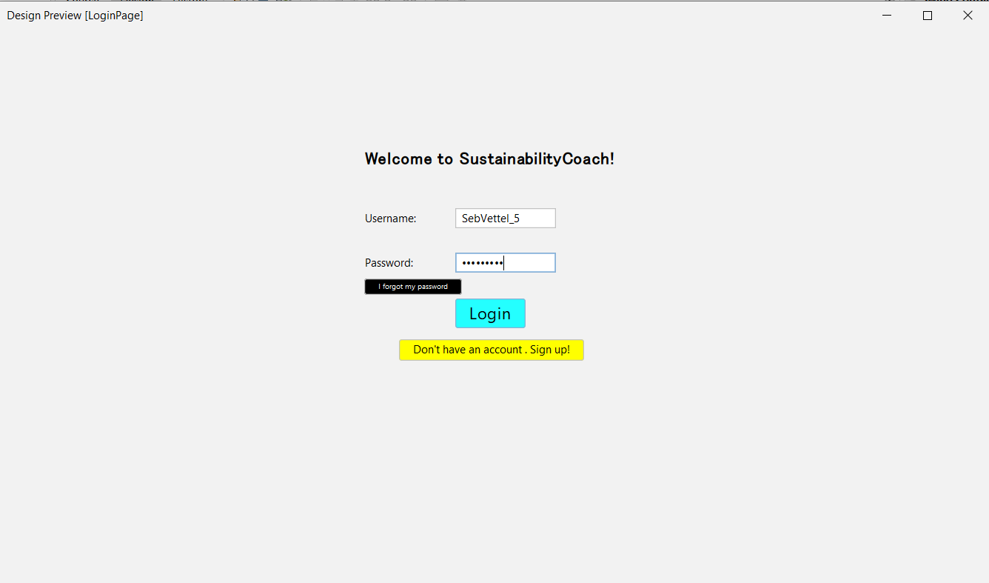

Figure 1

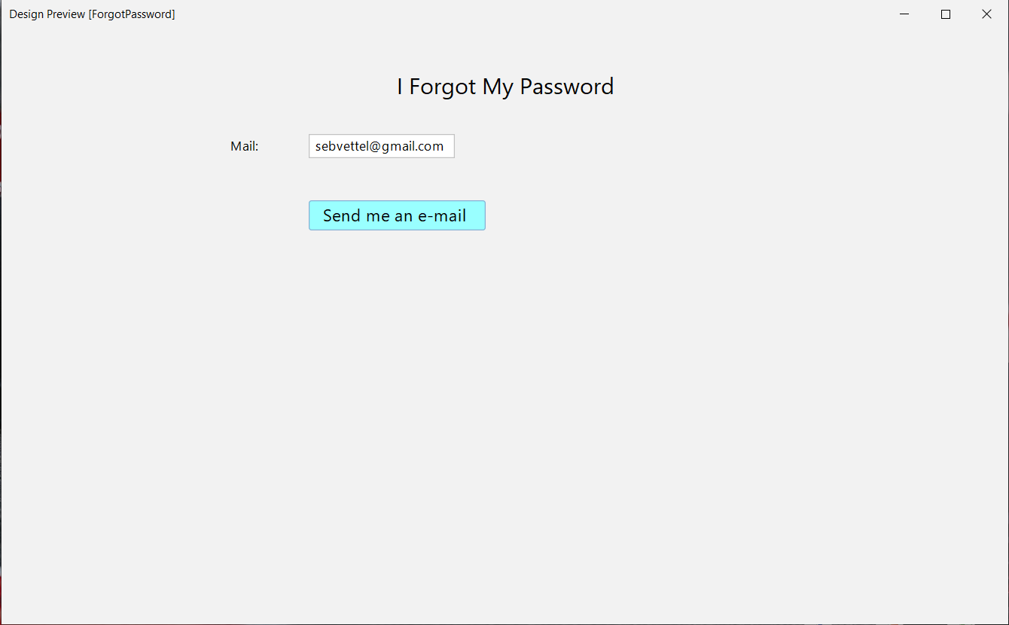

Figure 2

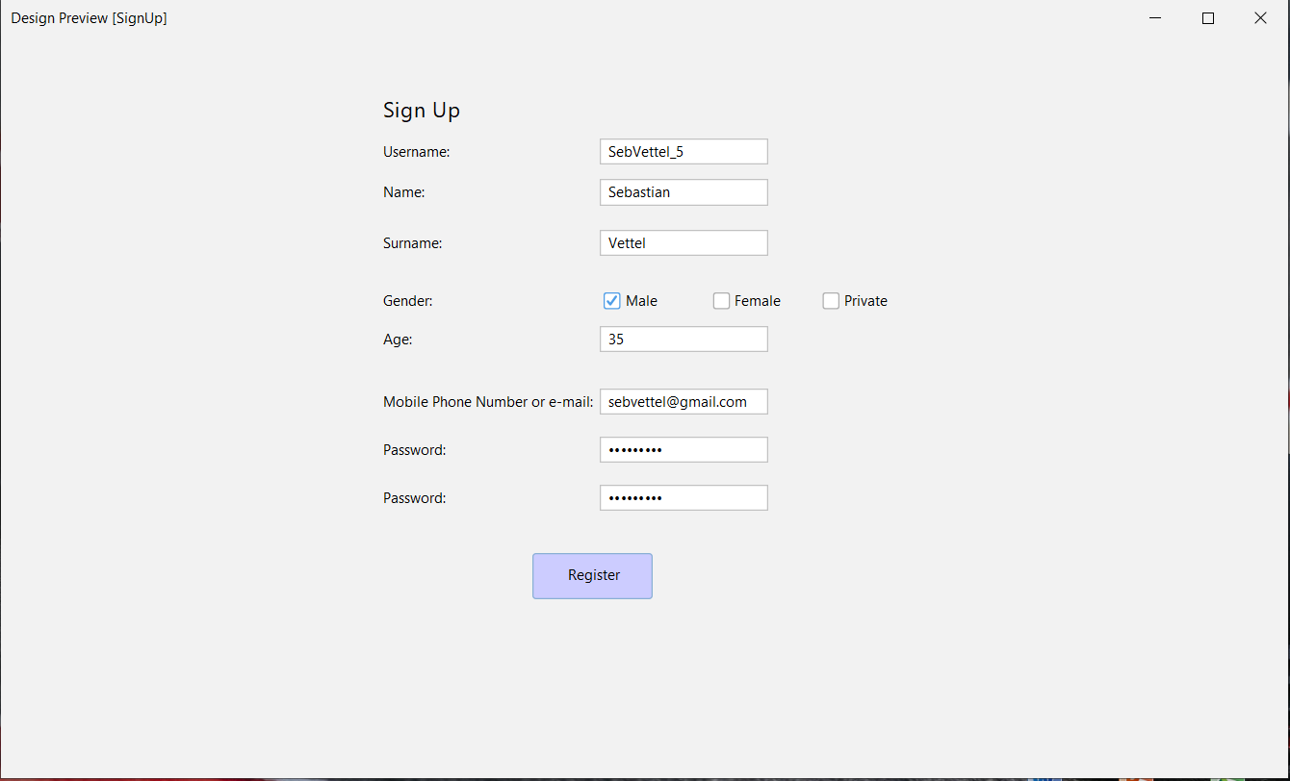

Figure 3